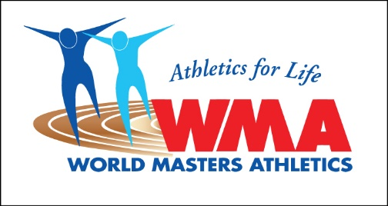

WORLD MASTERS ATHLETICS

IN COOPERATION WITH THE IAAF

EXPRESSION OF INTEREST TO BID FOR WMA OUTDOOR (STADIA) CHAMPIONSHIPS

Pursuant to its Constitution, By-Laws and other rules of WMA we, the undersigned, wish to formally express an interest in hosting the following WMA Championship Indoor in the year 2023. Following a Formal Documented Bid it is agreed to pay for the visit as outlined below. Letters of support from the organisations below are also enclosed.

Name and Signatures

The City/Town (Mayor) Name ____________________________

Signature ____________________________

The local/regional organisation (LOC) Name ____________________________

Signature ____________________________

The IAAF National Governing Body Name ____________________________
for athletics
Signature ____________________________

The Masters Affiliated Body Name ____________________________

Signature ____________________________

Government Immigration Representative* Name ___________________________

Signature ____________________________

* It is recommended that the Government Immigration Department responsible for the granting of Visas to enter the country be advised of the pending bid for a WMA Championship and be a signatory to the Contract. (WMA Contract 2, & 3.1)

The National Masters Body is also required to inform the WMA Regional President of their involvement in this Expression of Interest.

WMA Inspection Visits

The LOC, as a bidder for a World Masters Athletics Championships Indoor, shall be obliged to pay the travel, accommodation and meal costs for up to five (5) persons designated by the WMA President to make a site evaluation visit to the City/Town of _______________________ prior to reporting to the WMA Council on the proposed bid.

The persons attending the site evaluation visit (not longer than three (3) days and nights), may consist of the WMA President, the Vice President, the Vice President of Competition and the IAAF Representative.

Such visits are made prior to a bid being approved and then prepared for presentation at the next WMA General Assembly.

LOCATION OF THE CHAMPIONSHIPS
The 2023 WMA Indoor Championships are to be held in and around the City/Town of

_______________________.

Signed by Name Post
Chair of LOC
________________________ _______________________

City/Town stamp

Please return this Form to WMA Secretary, María Alfaro, by 1st September 2019.

All other Formal bid documents as outlined in the Contract must be received by 1st October 2019 for the bid to be considered and accepted.

María Alfaro
WMA Secretary

