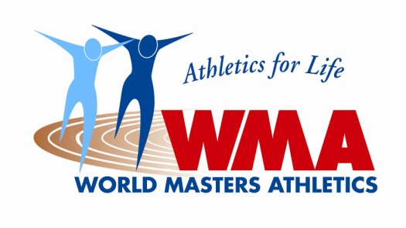

WORLD MASTERS ATHLETICS

IN COOPERATION WITH THE IAAF

EXPRESSION OF INTEREST TO BID FOR WMA CHAMPIONSHIPS STADIA

Pursuant to its Constitution, By-Laws and other rules of WMA we, the undersigned, on behalf of: ______________________________________________________________________________
(name of Bid Organisation legally responsible for conducting the event),

wish to formally express an interest in hosting the following WMA Championship Outdoors (Stadia) in the year 2024. Following a Formal Documented Bid it is agreed to pay for the visit as outlined below. Letters of support from the organisations below are also enclosed.

Name and Signatures

Name of Bid Organisation Name ____________________________
or Person Legally Responsible for
Conducting the Championship Signature ___________________________

The City/Town (Mayor or Representative) Name ____________________________

Signature ____________________________

The local/regional organisation (LOC) Name ____________________________

Signature ____________________________

The IAAF National Governing Body Name ____________________________
for athletics
Signature ____________________________

The Masters Affiliated Body Name ____________________________

Signature ____________________________

Government Immigration Representative* Name ___________________________

Signature ____________________________

* It is recommended that the Government Immigration Department responsible for the granting of Visas to enter the country be advised of the pending bid for a WMA Championship and be a signatory to the Contract. (WMA Contract 2, & 3.1)

The National Masters Body is also required to inform the WMA Regional President of their involvement in this Expression of Interest.

-2-
WMA Inspection Visit
A site evaluation visit is made prior to a bid being approved and then prepared for presentation at the next WMA General Assembly.

When preparing a Bid for a World Masters Athletics Championships Outdoor (Stadia), the Bidder is required to allocate a fee of USD 20,000 in their budget to cover the cost for the site evaluation visit. The WMA Treasurer will provide bank account details to the Bidder, and this fee must be paid when submitting the Bid.

The WMA fee covers the cost of travel and other expenses incurred by the WMA evaluation team when making the inspection visit to the City/Town of _______________________ prior to reporting to the WMA Council on the proposed bid. In addition to the WMA fee, the Bidder is required to provide, at their own expense, accommodation and meal costs for four (4) persons designated by the WMA President for the site evaluation visit. At the conclusion of the evaluation visit, any portion of the WMA fee not expended in the conduct of the visit will be returned promptly to the Bidder.

The persons attending the site evaluation visit (not longer than three (3) days and nights), may consist of the WMA President, the two (2) Vice Presidents (Technical and Organisational), the IAAF Representative or other designated person.

LOCATION OF THE CHAMPIONSHIPS
The 2024 WMA Championships Outdoors (Stadia) is to be held in and around the City/Town of

_______________________.

Signed by Name Post
Chair of LOC
________________________ _______________________

City/Town stamp

Please return this Form to WMA Secretary, María Alfaro, by 1st September 2019.

All other Formal bid documents as outlined in the Contract must be received by 1st October 2019 for the bid to be considered and accepted.

Maria Alfaro
WMA Secretary

